Microsoft OneNote and Class Notebook 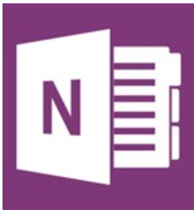
Agenda
Organize and share your files electronically using Office 365 One Note. Learn how you can create OneNote notebooks for cloud based organizations and file sharing. Dig deeper to deliver curriculum and collaborate with students and colleagues. This is a tool you've got to see!
TEAM Strand: TEAM: Presentation of Instructional Content
ISTE Teacher Standard - Develop and model cultural understanding and global awareness by engaging with colleagues and students of other cultures using digital age communication and collaboration tools.
- Introduction to OneNote (short video clip)
- Create a Notebook for Training name it Training Notebook
Notebook Settings
Options
Sharing a Notebook
- Home Ribbon
- View Ribbon
- Insert Ribbon
- Draw Ribbon
- Review Ribbon
- Send to OneNote
Email and Web
- Class Notebook Introduction (look at an example)
- Class Notebook Setup

